Lincoln Youth Homelessness Demonstration Program

AAQ (Ask a Question) Responses

As of May 5th, 2022
Is the entity that is awarded rapid response assistance (case management) obligated to match funds held by the common funder?

The required match obligation for any CoC-funded grant is 25% of the awarded grant amount minus funds for leasing. Cash or in-kind resources will satisfy the match requirement. (§ 578.73(a)). If a rapid response program does not include allocation of funds to the common fund there would be no match requirement for that program of funds allocated to the common fund by another rapid response program. The match required is 25% of the awarded amount.
As of May 4th, 2022
Should a budget narrative accompany the budget and is the budget part of the page limit?
Answer: As specified on page 9 of the RFP, 8. Project Implementation e. Budget. “Provide a clear budget for the project that supports the housing, services, and staff proposed. Costs should be reasonable, justified, and competitive. The budget must demonstrate the project is cost effective with costs not deviating substantially from the norm in that locale for the type of structure or kind of activity.” An applicant certainly could include a narrative to meet this criteria. A budget narrative included as part of the response to “Section 8. Project Implementation Plan e. Budget” is part of the 15 page limit. A line item budget table included as an attachment would not count toward the 15 page limit.

As of May 3rd, 2022:
Will the funds for Rapid Response Assistance be housed with the selected organization or with the common fundholder (LCF or Nebraska Children & Families Foundation)? If the funds are housed at the common fundholder (LCF or Nebraska Children), is a match for the entity applying required for the total rapid response assistance amount?

Answer: Financial assistance funds as part of a Rapid Response project will be held by the Common Fundholder. Required HUD Match should be specified as part of the proposal, including the financial assistance.
The format for the Proposal Components outlined in the RFP is different than the scoring criteria format provided in the RFP. Which format structure is recommended for a full program proposal?
Answer: The proposal format should generally follow the Proposal Component outline specified in the RFP. It is recommended that applicants review and include within the proposal responses that address all items specified within the scoring criteria. Applicants can determine the most appropriate section of the proposal to address each specified scoring criteria as it fits their narrative.

As of April 28, 2022:
For joint applications as noted on page 4 of the RFP, should one collaborative application with the information from each agency and the collaborative approach be submitted OR should each agency submit an independent application?

Answer: For collaborations, one application can be submitted. Joint applications should submit an MOU reflecting the role of project partners and specify funding for each organization in the detailed budget.

Can you clarify what “utilize the Lincoln Prevention Assistance Common Fund” means regarding the special considerations for Rapid Response Assistance projects?

Answer: The Lincoln Prevention Assistance Common Fund is a coordinated, citywide response that provides rent, mortgage, utility, and other needed financial assistance to households in need to prevent homelessness and increase housing stability. Proposals should align with the community plan and propose how projects would align Rapid Response Assistance with the common fund model established for the City of Lincoln.

More information about LPAC can be found here: https://www.lincoln.ne.gov/City/Departments/Urban-Development/Housing

Is there a supportive service cap (e.g. 20%) for permanent supportive housing projects?

Answer: No, there is no supportive service cap for YHDP funded projects.

Is it allowable to include a web/video link within the proposal?
Answer: Responses should be limited to narratives meeting the required format of 15 pages, single spaced at 12. pt font.

I would like to try to clarify the ages to be served in PSH, the community plan indicates 19-24 but the RFP states, youth experiencing homelessness ages 18-24.
Answer: Clarification on ages- Youth Homelessness Demonstration Project (YHDP) can serve unaccompanied youth up to the age of 24, including pregnant and parenting youth, who meet Category 1, 2, OR 4 of homelessness in HUD’s Final Definition of Homeless.
More information on determining the homeless status of youth can be found here: https://files.hudexchange.info/resources/documents/Determining-Homeless-Status-of-Youth.pdf

As of April 21, 2022:
Are the Eligible YHDP Program costs below allowable within the Coaching and Navigation Project (SSO) in addition to staffing costs:

- Security deposits for units in an amount not to exceed 2 months of rent;
- The costs to pay for any damage to housing due to the action of a program participant, which may be paid while the youth continues to reside in the unit. The total costs paid for damage per program participant may not exceed the cost of two-months’ rent.
- The costs of providing household cleaning supplies to clients.
- Housing start-up expenses for program participants, including furniture, pots and pans, linens, toiletries, and other household goods, not to exceed $300 in value per program participant.
- The one-time cost of purchasing a cellular phone and service for program participant use, if necessary for the participant to obtain or maintain housing
- The cost of internet in a program participant’s unit.
- Payment of rental arrears consisting of a one-time payment for up to 6 months of rent in arrears, including any late fees on those arrears.
- Payment of utility arrears of up to 6 months per service.
- Up to three months of utilities for a program participant, based on the utility costs schedule for the unit size and location.
- In addition to transportation costs eligible in 24 CFR 578.53(e)(15), a recipient may pay gas and mileage costs for a program participant’s personal vehicle for trips to and from medical care, employment, childcare, or other services eligible under this section.
- Legal fees, including court fees, bail bonds, and required courses and equipment.
- Program participant’s past driving fines and fees that are blocking a young person from being able to obtain or renew a driver’s license and impacting their ability to obtain or maintain housing. Additionally, recipients may pay for program participants costs for insurance and registration for personal vehicles, if the personal vehicle is necessary to reach medical care, employment, childcare, or other services eligible under this section.

ANSWER: Technically yes, that program flexibility is an allowable program flexibility under the HUD YHDP COC NOFO under these conditions;
a. The following YHDP activities may be exercised by YHDP recipients with notice to the Deputy Assistant Secretary for Special Needs, subject to requirements governing grant agreement amendments at 24 CFR 578.105
Programs are encouraged to explore all program flexibilities as innovative activities in Appendix D of the RFP in their proposals.
In addition: The slide below listed Leasing as an Eligible YHDP Program Cost under Coaching/Navigation “SSO”. Can we be provided more information on how leasing would be an eligible YHDP program cost for this Project?
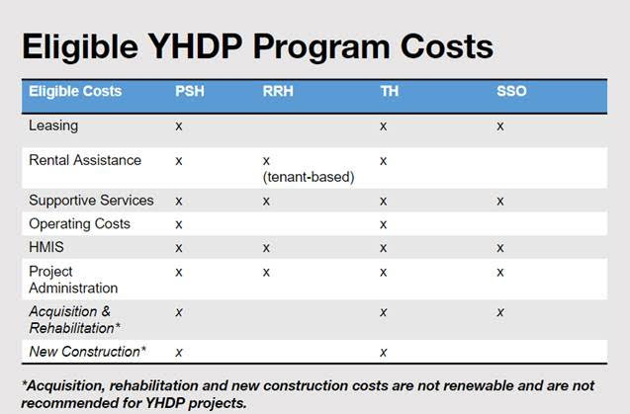
ANSWER: The CoC Interim Rule specifies which eligible supportive services can be paid for with the CoC Supportive Services funds, including YHDP. Information on eligible supportive services can be found here: https://www.hudexchange.info/homelessness-assistance/coc-esg-virtual-binders/coc-eligible-activities/supportive-services/
Applicants are encouraged to follow project descriptions in Appendix A in their proposals.

As of April 19, 2022
Clarification on oversight in RFP.
From Appendix A (page 11): Project Description
The following statement should have been included in the Rapid Response Assistance Summary. “Special Consideration: Rapid Response Assistance projects must utilize the Lincoln Prevention Assistance Common Fund.” 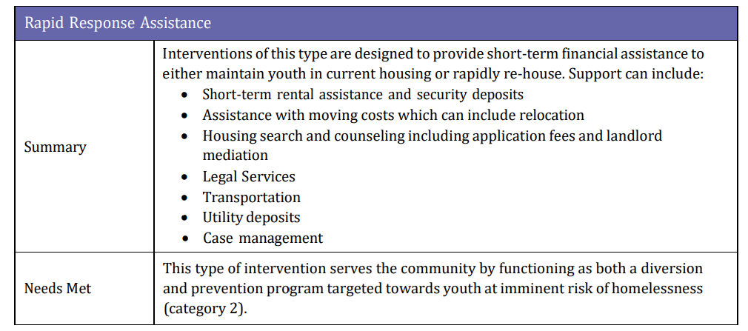

As of April 14, 2022:
From the slide below is the “Project $ Est. Range” per funded project per year? Also, is the “Estimated # of Youth HH Served Per Year” per funded project (20-30 per funded project or 10-15 per funded project if 2 approved projects)?
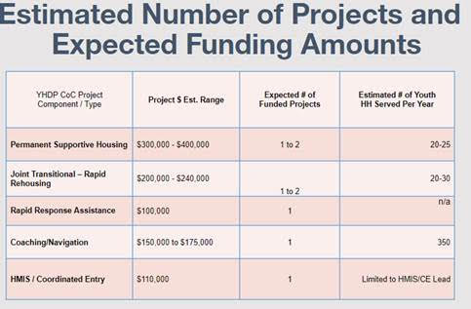
ANSWER: Yes, the amount of project estimated range is per year. The estimated number of youth HH served per year is total per component type. – i.e. it is estimated that all YHDP funded PSH Project(s) would serve 20-25 youth a year.
In addition, in regards to the “Non-Binding Letter of Intent” due April 15th, is there anything specific that needs to be on the letter (type of project, collaboration, etc.) or just a statement that the agency will be submitting an application for YHDP?
ANSWER: Letter of intent should include at a minimum type of project/component agency intends to apply for.

https://www.hud.gov/sites/dfiles/CPD/documents/FY21-YHDP-Appendix-A-Final.pdf

