Step-by-step instructions to enroll in benefits

- Open Oracle from Home Intranet.

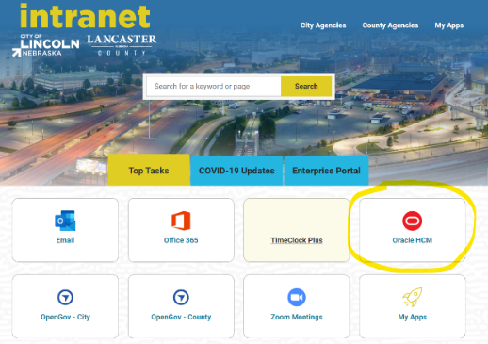
- Click the “Benefits” tile.

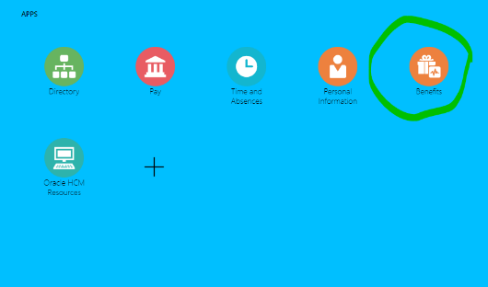

- Click the “Before You Enroll” tile.

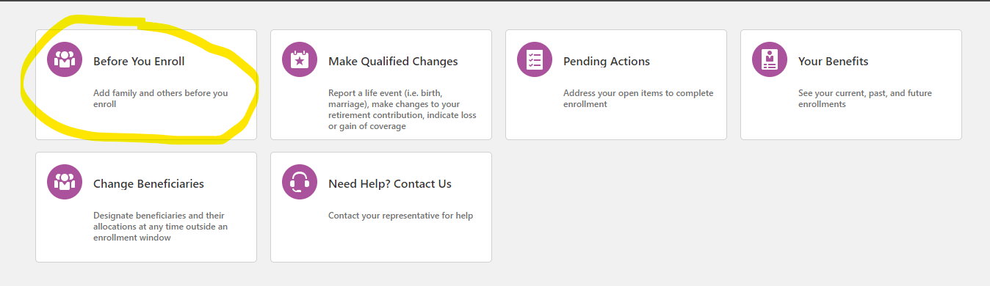

- If you are adding a spouse and/or dependents for benefits coverage or as a beneficiary, click on the “+Add” box for each person and provide the following information.

On “Basic Information” tab: On “National Identifiers” tab:
Last Name Social Security Number
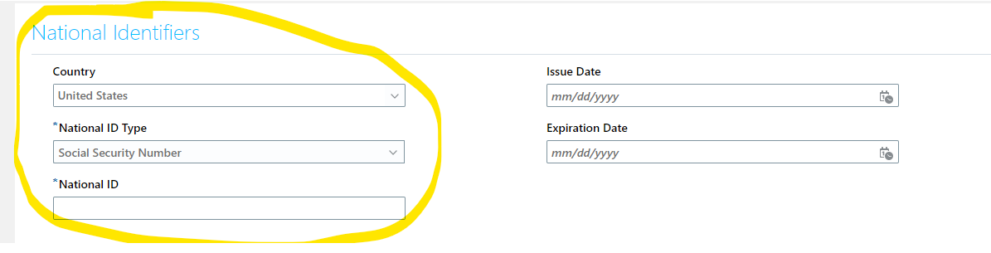
First Name
Relationship
Gender
Date of Birth
Start Date of Relationship (your employee start date)

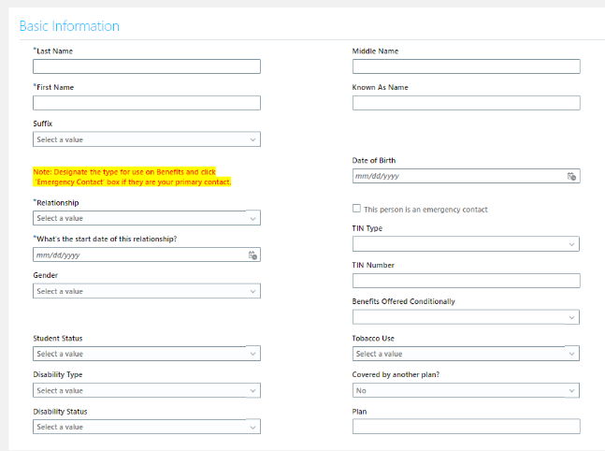

Click “submit” after each dependent/beneficiary.

- Click “accept”

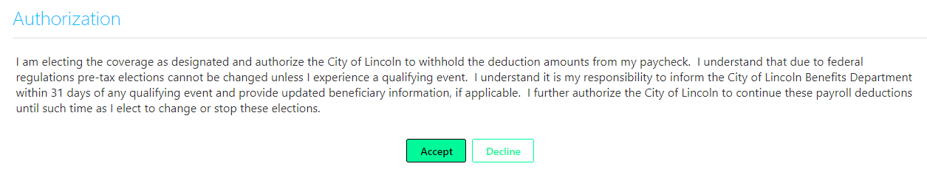

- Open “Your Benefits” tile

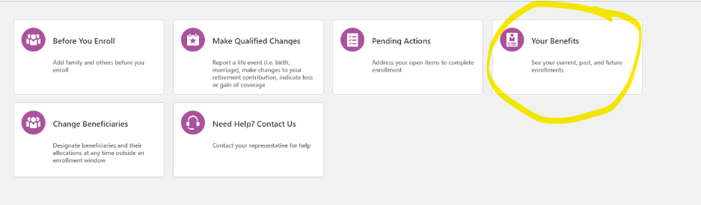

- Click the “edit pencil” on the far-right side of the screen.

- For each benefit you would like to enroll in, select the coverage type (Employee only, Employee + Spouse, Employee + Child(ren) or Family) and choose who you would like to cover. You may also choose “waive coverage”.

Scroll to each benefit and follow the same procedure until you have made all your elections.

Click the box with the tier level you would like to elect (Employee only, Employee + spouse, Employee + children or Family).
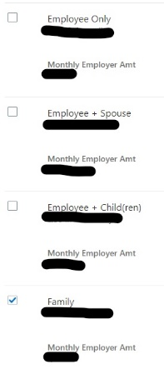

If you choose an option other than employee only, your “people to cover” will appear in the box, click the boxes of the people you would like to cover.
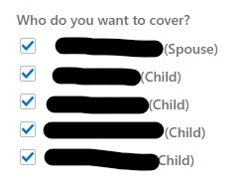

- Be sure to designate beneficiaries for Life Insurance.

- Click the green “OK”.

- Scroll to the top of the page and click “SUBMIT”.
You are now enrolled in your City of Lincoln benefits!

If you would like to print a confirmation page for your records, follow these steps:

- Go back to your home dashboard click “Benefits”
- click “Your Benefits”

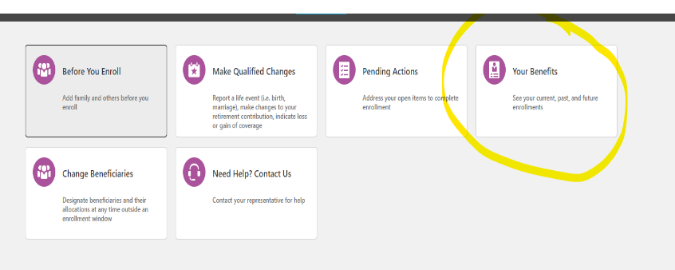
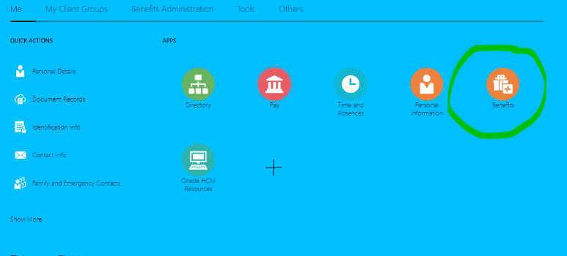

- Click on the drop-down box and choose “Specific Date”
- Enter your effective date of coverage,

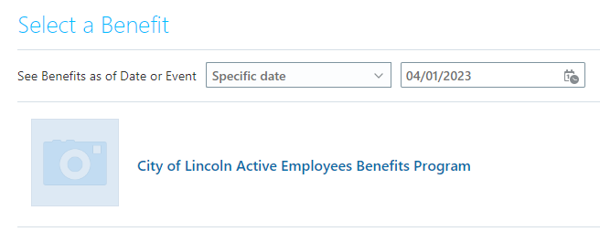
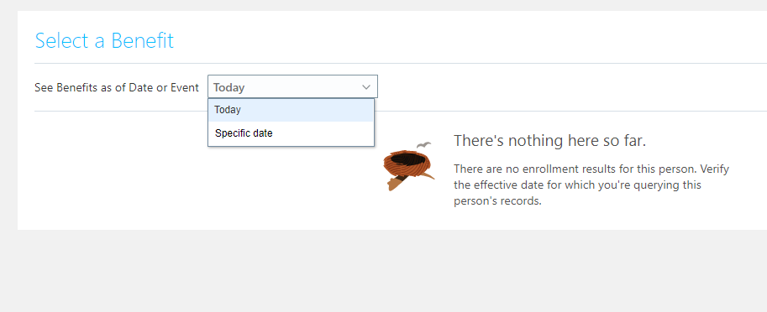

- click the “print” button on the upper right-hand corner of the page
(it will print as a PDF on your screen; you must select a printer for it to print to).

